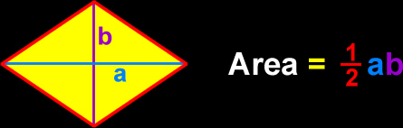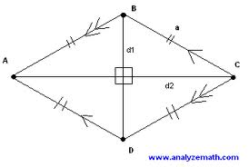

# At Los Rhombus we create a fun environment for all shapes with equal side lengths and side lengths. !!

Facts about Los Rhombus

Welcome to Los RhomBus!

1. Has four congruent sides
2. Opposite sides parallel
3. Opposite angles congruent
4. Diagonals bisect each other
5. Diagonals bisect opposite angles
6. Diagonals are perpendicular

Historical Family Members who have visited:

The rhombus is family member with the popular parallelogram and also has family lineage with the square and rectangle.

## Come and Visit our Local Beach Front Restaurant

The restaurant contains four sides each with a length of 2000 feet to create a total perimeter of 8000 feet for water fun and good food. The area of the restaurant is 4 million square feet. The kids will have a great time running around the park while the parents get to sit back and relax.

There are two slides that go from one corner of Los Reyes to the opposite corner. These slides intersect in the middle of the part in a 90 degree fashion that creates a great meeting place for friends and family.