Victoria Brown
IT 7360
Spring 2013
A03 Develop Lesson Plan 1 and Concept Map

Lesson- Determining Types of Quadrilaterals beginning with Slope
Standards:
GPS-
MCC9-12.G.GPE.4 Use coordinates to prove simple geometric theorems algebraically. For example, prove or disprove that a figure defined by four given points in the coordinate plane is a rectangle; prove or disprove that the point (1, √3) lies on the circle centered at the origin and containing the point (0, 2).

Common Core-
11. Prove theorems about parallelograms. Theorems include: opposite sides are congruent, opposite angles are congruent, the diagonals of a parallelogram bisect each other, and conversely, rectangles are
parallelograms with congruent diagonals.
Learning Objectives:
- Students will be able to use coordinates to prove simple geometric theorems algebraically.
- Students will be able to make conjectures and then prove these conjectures using mathematics.
- Students will be able to explain their conclusion with the use of the distance, slope, and midpoint formula.

Essential Questions:
What conditions are necessary to prove a specific quadrilateral given coordinates?
Lesson Plan:
Engage- I will begin the lesson by giving each group of four students a different shape that is defined by four coordinate points. They will work within their group to determine what type of quadrilateral is given to them. We will come back to these shapes at the end of the lesson to see if the students would like to re-evaluate their decision based on what was learned throughout the lesson.
Explore- During this part of the lesson, the students will be looking into different characteristics of each quadrilateral in order to determine the appropriate classification. They will use the information that they know about each shape as well as formulas to help them determine the type.
Explain- The students will use the distance, slope, and midpoint formulas in order to test their hypotheses and come to conclusions based on the information. They will have to show all conditions and give the most specific shape possible. (Ex. It is not enough to say it is a square because all sides are the same.)
Elaborate- The students will have to actually show the work for finding all side distances, slopes, and criterion necessary instead of just listed out the characteristics that are needed. The students will use GeoGebra as a tool to investigate the different shapes and possibilities.
Evaluate- The students will complete a homework assignment to check for a solid understanding of the material and all necessary standards. This homework will be checked the next day in class with the students providing answers and explaining the solutions to their peers.
Extend- The students will finish their homework by trying an extension problem that has them look into finding a fourth point to a specific type of quadrilateral if three other points are already known. The students will have to apply their previous knowledge and work on a true understanding and application of the material.
Technology Integration
The concept map will be filled in at the conclusion of the lesson through discussion with the students about the information that they learned in the lesson and then they will be given a copy of the filled in concept map for their own use as a resource tool. The completed concept map that the students will receive at the end of the lesson as a resource is attached to this lesson plan as a separate document.
Assessment
The students will each be given a homework assignment to gain some more experience and practice working with the concepts of the lesson. The homework will be graded using the following rubric:
3 problems worth 5 points each
1 point for right type
2 point for the verification
1 point for the midpoints or diagonals
1 point for the conclusion
Bonus- 2 points

Homework Assignment:
1) Quadrilateral ABCD A(7, -1) B(3, 6) C(-1, -1) D(3, -8)

Quadrilateral Type : Rhombus

Verify:

Slopes are not opposite reciprocals- $m_{AB}=-\frac{7}{4}and m_{BC}=\frac{7}{4}$

$AB=BC=CD=DA=\sqrt{65}$

Find the length of each diagonal. $AC=8 and BD=14$

Conclude: The lengths of the diagonals in a rhombus are not congruent

2) Quadrilateral ABCD A(1, 1) B(-2, 4) C(-5, 1) D(-2, -2)

Quadrilateral Type: Square

Verify:

$AB=BC=CD=DA=\sqrt{18}$

$m_{AB}=-1, m_{BC}=1$so the angles are perpendicular

Find the slope of each diagonal. $m_{AC}=0, and m_{BD}=undefined$

Conclude: diagonals of a square are perpendicular

3) Quadrilateral ABCD A(-1, -1) B(1, 2) C(6, -3) D(4, -6)

Quadrilateral Type : parallelogram

Verify:

$m_{AB}=\frac{3}{2}, m_{CD }= -1, m_{CD}= -1$ so opposite sides are parallel

$AB=\sqrt{13} and BC=\sqrt{50}$ so the sides are not the same length

Find the midpoint of each diagonal. $midpoint AC=midpoint BD=(\frac{5}{2}, -2)$

Conclude: the diagonals of a parallelogram bisect each other

Bonus:
Plot points A(-4, 6) B(8, 10) C(11, 1). Find point D that makes ABCD a rectangle. Verify that it’s a rectangle.
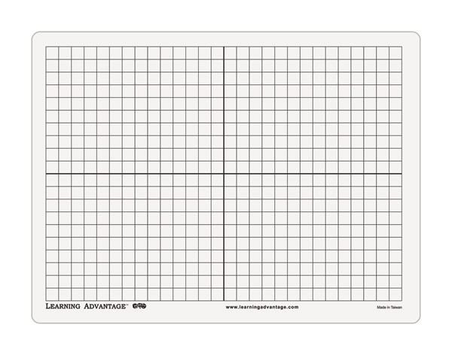

D(-1, -3)
Lesson Problems:
- Prove or disprove that the following points are a kite. A(-3, -2) B(-1, 1) C(2, 3) D(3, -3)

- Prove or disprove that the following points are a rhombus. A(-1, 3) B(3, 5) C(5, 1) D(1, -1)

- Prove of disprove that the following points are a parallelogram. A(-2, 8) B(2,7) C(5,1) D(1,2)

- Prove of disprove that the following points are a rectangle. A(-4, 6) B(8, 10) C(11, 1) D(1, -3)

Questions to ask the students throughout the lesson to get them thinking about the content and involving the 6 E’s:
- What is the easiest characteristic to find from a quadrilateral when given four sets of points?
- Is it enough to always base conclusions off the look of the shape?
- What steps are necessary to prove a quadrilateral?
- What are the properties of each of the following quadrilaterals: rectangle, rhombus, parallelogram, kite, trapezoid, and isosceles trapezoid?
- How do you know that you have verified enough information to prove the quadrilateral?
- Would any of you like to make modifications to your original conclusions and why?

